

YelpMark

Development Document

Team SAMM

|  |  |
| --- | --- |
| Seungwoo Lee | [sl3492@columbia.edu](mailto:sl3492@columbia.edu) |
| Alexandros Sigaras | [as4161@columbia.edu](mailto:as4161@columbia.edu) |
| Michael D’Egidio | [mad2144@columbia.edu](mailto:mad2144@columbia.edu) |
| Morris Hopkins | [mah2250@columbia.edu](mailto:mah2250@columbia.edu) |

Contents

Chapter 1: Overall Process 4

Application Design 4

Application Development 4

Application Debugging 5

Overall Refinements and Documentation 5

Creating the Video and the Presentation 5

Creating the Video 5

Creating the Presentation 6

Chapter 2: Target Users 7

Target Users Description 7

Persona detailed description 7

Persona 1 - Meg 7

Persona 2 - Jim 7

User Scenarios 8

Scenario A - Meg 8

Scenario B - Jim 9

Chapter 3: Design Decissions 10

Chapter 4: Prototyping and testing process 11

Phase 1 11

Phase 2 12

Phase 3 13

Add designs 15

Phase 4 15

Chapter 5: Software Engineering 16

Third-party libraries used 16

Tools used 16

Code editors 16

Versioning Control 16

Debugging 16

FTP Client 16

Image Editing 16

Video Editing 16

Presentation 16

# Chapter 1: Overall Process

The overall process of creating YelpMark could be easily separated in 5 distinct parts:

* Application Design
* Application Development
* Application Debugging
* Overall Refinements and Documentation
* Creating the Video and the Presentation

The timeline of the parts above can be shown in the figure below (Figure 1)

Figure - Overall Process Timeline

## Application Design

The application design was one of the most important parts of our overall process. Every team member contributed in this part, as we wanted every good idea to be expressed and included in our application. Our application design process is depicted in more detail in chapters 4 & 5.

## Application Development

To optimize in terms of speed and quality our application development we used a versioning control (***Github***). Then we equally distributed development roles amongst each member of the team. A higher level approach of that roles and responsibility assignment can be found in the figure below (***Figure 2***).

Figure - Application Development Role & Responsibility Assignment

## Application Debugging

The approach used for application debugging was to stress test each other’s code and create a pool of bugs to fix. We identified the bugs in terms of severity and crosschecked them with bugs that we received as feedback on user testing.

## Overall Refinements and Documentation

Having completed the creation of YelpMark we merged our roles and responsibilities to act as one again and revisited our use case scenarios. Then, we created our ***User Manual*** and the ***Development Document*** depicting all the work done in detail.

## Creating the Video and the Presentation

Since the video and the presentation showcases the results of our team work, every team member participated and equally contributed in the creation of the video and the presentation.

### Creating the Video

We decided to use Jim’s use case scenario to showcase our application as we considered that it provided a good overview of the application’s functionalities and general capabilities. Overall:

* An iPhone 5 was used to shoot all videos.
* SnagIt was utilized for screen recording.
* iMovie was used to bind all of the videos together and apply additional effects.

### Creating the Presentation

To create the final presentation, the education edition of prezi was extensively used due to its ability to deliver the essence of a project in a minimal approach wrapping.

# Chapter 2: Target Users

## Target Users Description

The class of users that we wish to target with our optimized Yelp application regards young urban professionals, ranging from 25 to 30 years old. Being recent graduates with above average disposable income or graduate students specializing in their field, they can afford to stay at the cutting edge of technology. These users tend to spend a lot of their free time exploring new venues in their neighborhoods such as restaurants, bars, nightclubs, cafes, and concert halls. It is typical for this class of users to have significant exposure to new technology and to be comfortable exploring many of the features of application.

## Persona detailed description

### Persona 1 - Meg

Meet Meg. Meg is more than just a rookie consultant at Deloitte (one of the most prestigious consulting firms in the world). After graduating from Columbia Business School three years ago, Meg has risen among the ranks of the most talented business consultants in Wall Street.

Although having above-average computer usage skills, Meg is certainly not a professional. She can dazzle you with a PowerPoint or a scripted-out-the-wazoo Excel spreadsheet but when it comes to her knowledge of Internet applications, she’s an intermediate user at best. This lack of dedication to learning the ins and outs of web programs is justifiable: Meg is too busy with her crazy work schedule to get into the nitty-gritty settings of her web applications; Meg wants the most information using the least amount of effort. Time is money in Wall Street!

### Persona 2 - Jim

Meet Jim. Jim is a Columbia University MSc student in Computer Science. Tech savvy and Internet guru, Jim has no trouble using Internet based applications. YelpMark is certainly Jim’s favorite, helping him explore new venues in New York City and amaze his friends.

For him, when it comes to using any kind of application, he tries to explore and understand all of the applications features and functionality so that he is capable of taking full advantage of what it is has to offer. He is an advanced user.

## 

## User Scenarios

### Scenario A - Meg

Luckily for Meg, this weekend is her big chance to seal the deal of a lifetime. Deloitte is brokering a huge merger between two Japanese electronics super-giants, Sony and Panasonic. It has been left up to her discretion where to take these two high-power CEOs out to dinner. All Meg knows is that she has to find the best meal Deloitte can afford in order to cement this colossal merger. Unfortunately the meeting is taking place in San Francisco and Meg has no idea which restaurant is the best choice there.

Meg is now at the JFK airport waiting for her boarding to start. She decides to go to ***YelpMark***, find a number of restaurants that her clients may potentially enjoy for their meeting and bookmark them so she can make the final decision once she reaches San Francisco. She opens up her laptop using the airports WiFi and navigates to [www.yelpmark.com](http://www.yelpmark.com). Once the application loads a message appears asking Meg if the application can use her current location. Since Meg is currently in New York City and wants results for San Francisco she clicks ***No***.

Meg types ***restaurants*** into the text box that says: ***Find*** and ***San Francisco*** into the textbox that says: ***Location***. Search results now fill the ***Search Results*** column on the right, distinct categories for filtering appear exactly above her ***Search Results*** column and the map now being set to ***San Francisco*** contains pushpins of the location of all of her results.

Since Meg wants only the best rated restaurants she decides to filter by rating and selects ***4 stars +***. Search results are now refined but there is still work for Meg to find the perfect restaurant. She decides to narrow it even further by selecting from the available categories the ones that may appeal to her clients.

She quickly goes through the ratings and the reviews and decides to bookmark some of them to make reservations once she lands in ***San Francisco.***

When Meg arrives in San Francisco and goes to her hotel, she navigates again to YelpMark allowing geolocation use this time. All of her previously stored bookmarks now load both into the map that appears in the center of the screen and into a ***Bookmarks*** column on the left side of the screen. She sees her own location and the location of each restaurant she bookmarked earlier. Clicking on the pushpin gets all the information she wants rating, latest review, restaurant contact details and driving directions from her hotel. Meg makes a final decision, brings up the restaurant information, calls the restaurant and books a reservation.

### Scenario B - Jim

This time Jim totally forgot to make reservations for dinner with his girlfriend. To make things even worse, his User Interface Design assignment is due tomorrow so he doesn’t have enough time to go around to find a restaurant. Without a second thought, he navigates to YelpMark, where he can search for restaurants near him, bookmark them and finally ask his girlfriend what she prefers. Because his girlfriend is also student, they enjoy eating at moderately priced Italian restaurants or Mexican food.

Jim navigates to YelpMark.com. When the allow location prompt appears he clicks allow. On the left hand side he sees all of his bookmarks and several red pins on the map. Jim clicks on the microphone button in the search box and speaks restaurants. He then clicks the search button. He sees the results display in the search results panel on the left and many blue markers drop down onto the map. He looks at the search results and decides to scroll down to see more results. When he scrolls to the bottom of the search results panel more results automatically appear in the list and more pins drop down onto the map. Jim knows that he wants to go somewhere kind of nice so he uses the filter by star option at the top of the search results. He selects more than 3 stars. The search pins reload onto the map and only valid results appear in the results panel. He wants to only see Italian or Mexican restaurants so he deselects all other category boxes. Only Mexican and Italian restaurant results appear. He looks through the results and finds a restaurant nearby. He clicks on the more info button and sees the rating, address, and phone number. He wants to go and needs to know how to get there so he clicks the directions button. The directions display. He’s in a hurry so he leaves the application running and leaves to get his girlfriend.

After a very enjoyable experience at the restaurant Jim decides to make a bookmark so he can find it again later. He gets back on his computer and clicks the add bookmark button. This allows him to enter some tags and comments. In the tags he enters “great Italian” and in the comment he writes “I had a great experience on date night.”

# Chapter 3: Design Decisions

**Used voice search and different colors on the pins for accessibility reasons**

**Map Vs Text Results accessibility**

There were a number of key design decisions that had a significant impact on the direction of our program.

* Our key design decision was to maximize the amount of workable screen space by allowing our two main windows to be scrollable. Scrollable windows allow us to truly take advantage of screen space without bombarding the user with excessive amount of displayed data (retention information). We followed standard design implementation designs such as use of sidebars that are in common locations such as absolute left and absolute right of the screen. This is to afford the user the shortest amount of time needed to understand how to navigate and utilize our application.
* We decided it was important to allow our users to harness the power of a map driven application.
* With the expending market for mobile applications we found it very relevant to provide users with the geographic visualization of their bookmarks utilizing Google Maps.
* The use of Google maps affords users the ability to direct themselves to the locations of interest allowing users to use their bookmarks in a way that has yet to be introduced in Yelp.
* We can get door to door driving directions using our application which helps to broaden both the use of our app and the number of people that may find interest in our application
* In regards to accessibility, we ensured that visually impaired people (CCVIP) would have an easier time reading high contrast text. Thus we ensured that the foreground and background colors were always distinct and contrast distinctly with the fonts.
* For users who have difficulty typing or are on devices that do not allow for rapid text input we provided a Google driven voice recognition service.
* To easily distinguish bookmarks from driving directions we used two different color pin markers. This is ideal for users with vision impairments.
* We decided that it would best for relevant information to be displayed in modal windows. Modal windows are convenient because they do not require the user to navigate off the current page or search. This is very useful because we know that having to redo a search is cumbersome. We want to make sure that the user has to perform the least number of requests to the application as possible.
* Allowing the user to filter data was also another important design decision. We accomplish this by using checkboxes in a scrollable div. This allows us to have a large level of granularity without taking up too much space on the screen.

# Chapter 4: Prototyping and testing process

Both the prototyping and testing process played a vital role in creating YelpMark.   
  
Our prototyping process allowed us to come up with a prototype that would fulfill our design decisions without violating any of Nielsen’s Ten Usability heuristics, while providing additional accessibility features for the visually impaired people (CCVIP).

Our prototyping process and testing process was divided in four phases (***Figure 1***).

Figure - Prototyping & Testing Process

### Phase 1

In our first phase, we used the rapid prototyping approach to quickly scribble and depict a general approach of the features of our application (Horizontal prototype).

Team members took turns and drew how they conceived the application. After a round of drawing prototypes we took every good idea and ended up with one combined design. We repeated the drawing process again but this time our drawings were based on the combined drawing. The outcome of the second round was our phase 1 drawing (***Figure 2***).

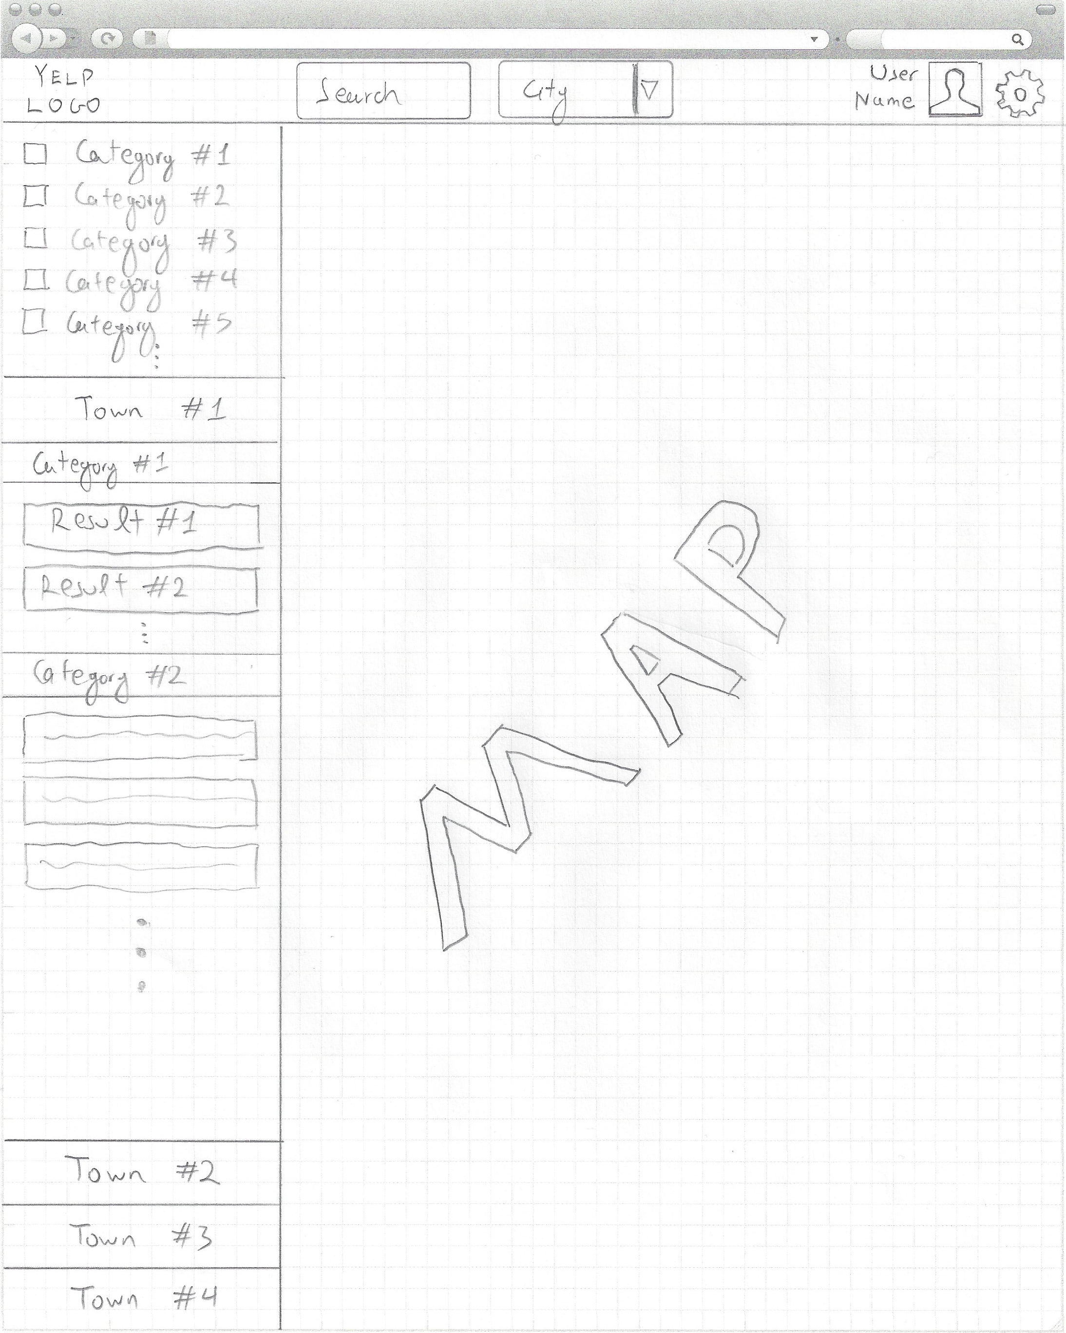

Figure – Phase 1 final Prototype

### Phase 2

In our second phase, we showcased our phase 1 final prototype to friends and classmates and gathered feedback regarding design issues that should be addressed. The feedback we received strongly suggested using a location textbox instead of a dropdown, so that the user could freely select the location and a simplified approach on the results.

We decided to enhance the search experience while keeping it minimal and reduce the results complexity by further reducing the user retention information applying Nielsen’s two heuristics rules:

* Aesthetic and minimalist design
* Recognition rather than recall

### Phase 3

In our third phase we used evolutionary prototyping approach to depict a refined and detailed approach to our application (Vertical Prototyping for each feature). (***Figure 3***).

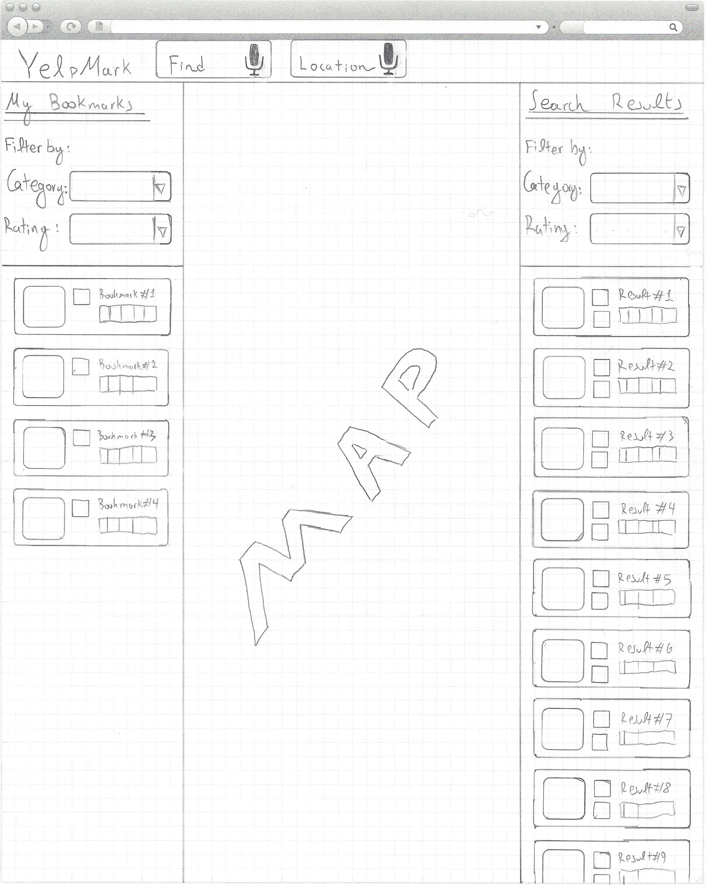

Figure – Phase 3 Final Prototype

### Phase 4

In our fourth and final phase, we showcased our phase 3 final prototype to the exact same audience as we did in phase 2 and gathered feedback regarding remaining design issues that should be addressed. The feedback we received was really positive and only minor improvements were suggested this time regarding sizing of objects and adding a borders on the map.

Furthermore since a majority of our test users had already a CS major, we asked whether they could do a stress test in our application and indicate any bugs and briefly state how to reproduce them.

To simplify the process we uploaded all our application in [www.yelpmark.com](http://www.yelpmark.com) and only required from the users to have Google Chrome installed. Over a set of 5 users, we got a report of 15 bugs in 7 of them that were distinct. We identified and reproduced these bugs and ranked them in terms of severity along with all the remaining bugs in our code to address them before finalizing the development.

# Chapter 5: Software Engineering

Throughout creating YelpMark, various third-party libraries and tools were used. More specifically:

## Third-party libraries used

Twitter Bootstrap <http://twitter.github.com/bootstrap/>

jquery - <http://jquery.com>

## Tools used

### Code editors

Sublime Text 2 - <http://www.sublimetext.com>

Coda 2 – <https://itunes.apple.com/us/app/coda-2/id499340368?mt=12>

TextMate – <http://macromates.com>

### Versioning Control

Github - <https://github.com>

Github UI for mac - <https://github.com>

Terminal - included with OS X

### Debugging

Developer Tools for Chrome – built-in in Google Chrome

### FTP Client

Transmit - <https://itunes.apple.com/us/app/transmit/id403388562?mt=12>

### Image Editing

Photoshop - <http://www.adobe.com/products/photoshop.html>

### Video Editing

SnagIt - <http://www.techsmith.com/download/snagit/default.asp>

iMovie – included with OS X

### Presentation

Prezi - <http://prezi.com>